**Forest Sale Automation**

**By**

**Anuj Anjirwala and Akash Patel**

**15BIT001 and 15BIT029**



**INFORMATION TECHNOLOGY DEPARTMENT**

**Ahmedabad 382481**

**Forest Sale Automation**

Submitted in fulfillment of the requirements

For the degree, of

**Bachelor of Technology in Information Technology**

By

**Anuj Anjirwala and Akash Patel**

**15BIT001 and 15BIT029**

Guided By

**INFORMATION TECHNOLOGY DEPARTMENT**



**DEPARTMENT OF COMPUTER SCIENCE & ENGINEERING**

**Ahmedabad 382481**

CERTIFICATE

This is to certify that the Seminar entitled “**FOREST SALE AUTOMATION**” submitted by **Anuj Anjirwala(15BIT001) & Akash Patel(15BIT029)**, towards the partial fulfillment of the requirements for the degree of Bachelor of Technology inInformation Technology of Nirma University is the record of work carried out by him/her under my supervision and guidance. In my opinion, the submitted work has reached a level required for being accepted for examination.

|  |  |
| --- | --- |
| Dr. Madhuri Bhavsar  Dept. of Information Technology,  Institute of Technology,  Nirma University,  Ahmedabad | Prof. Tejal Upadhyay  Assistant Professor,  Department of Information Technology,  Institute of Technology,  Nirma University,  Ahmedabad |

**ACKNOWLEDGEMENT**

Thanks to PROF. TEJAL UPADHYAY for his devoted guidance, the work she has done and guiding us through our topic and providing us with all necessary help at every point. Apart from our team work, the success of this report largely depends on the encouragement and guidelines of many others. The guidelines and suggestions for the Application were helpful to make our Web Application more interactive and user-friendly. We would like to Thanks “Department of Information Technology” for providing us with necessary and latest technology that help us in completing our work.

**ABSTRACT**

The aim of our project is to explore new avenue in computing like distributed system along with traditional concept like java script and networking. The project is about implementation of online service or website for forest authority to manage customer information with cost details, orders, deals, resource management etc. services. This project deals to overcome the drawback of manual method of maintaining records on every process inside forest department which is not effective method in present technology. The benefits of this project will be gain by both the client and authority. Time management, resource management, and mainly Forest management are cover under this project. Employment opportunities, advertisement, access to forest resources, partnership with NGO’s and associative education and research etc. are the key features of this project. Calendar event is important features of this project which is for the visitor. Mountain climbing, river rafting, Cycling, Zip line etc. are some event included in Calendar Event. Rear species of animal, highway through the forest so one can experience forest without leaving their car, people working as staff are from all over world are some feature of this project. This project is built under HTML, CSS, Java Script, PHP My Admin Database.

**CONTENTS**

Certificate III

Acknowledgement IV

Abstract V

List of figures

fig 3.2.1 Home section of Homepage 7

fig 3.2.2 Login section of Homepage 8

fig 3.3.3 About and Service section of Homepage 8

fig 3.3.4 Our Work section of Homepage. 9

fig 3.3.5 Contact Us section of Homepage. 9

fig 3.3.6 Login page of Project. 10

fig 3.3.7 Customer Details section of User Area 10

fig 3.3.8 Product Details section of User Area 11

fig 3.3.9 Order Details section of User Area 11

fig 3.3.10 Document section of User Area 12

fig 3.3.11 Terms and Condition sections of User Area 13

fig 4.1 Database Design 14

fig 4.2 Overview of Table in Database` 15

fig 4.3 User Table 16

fig 4.4 Product Table 16

fig 4.5 Order Table 17

fig 4.6 Customer Table 17

**Chapter 1 Introduction 3**

1.1 OVERVIEW OF THE SYSTEM 3

1.2 PROJECT CHARACTERISTICS 3

1.3 OBJECTIVE OF PROJECT 3

1.4 FEATURES OF THE PROJECT 3

**Chapter 2 Literature survey 4**

* 1. EXISTING SYSTEM 4
  2. DRAWBACKS 4
  3. PROPOSED SYSTEM 4
     1. NEED FOR NEW SYSTEM 4
     2. ADVANTAGES 5

**Chapter 3 Workflow 6**

3.1 REQUIREMENT OF SOFTWARE AND HARDWARE 6

3.2 WORKFLOW OF PROJECT 6

3.3 PROJECT SCREENSHOTS 7

**Chapter 4 Database Design 14**

4.1 DATABASE DESIGN 14

4.2 CORE CONCEPTS OF DATABASE 15

4.3 SCREENSHOTS OF DATABASE 15

**Chapter 5 Conclusion 18**

5.1 REFERENCES 18

**CHAPTER 1**

**Introduction**

* 1. OVERVIEW OF THE SYSTEM

The aim of our project is to explore new avenue in computing like distributed system along with traditional concept like java script and networking. The main aim is to provide online service for forest sale which is usually done offline. It is about forest sale management. The project is built under HTML, CSS, Java Script and PHP My Admin database. It is web Application which is only for Authorized user. User id and password are provided by forest authority only. Here user can view his current contract details, expired contract details, his/her details and can also manage contract.

**1.2 PROJECT CHARECTERISTICS**

USER AREA: -

* View Customer Details
* View Product Details
* View Order Details
* View Document
* View Contract Details
* View Terms and Condition

**1.3 OBJECTIVE OF THE PROJECT**

The main objective of this project is about implementation of online service or website for forest authority to manage customer information with cost details, orders, deals, resource management and many more services. This project deals to overcome the drawback of manual method of maintaining records on every process inside forest department which is not effective method in present technology.

**1.4 FEATURES OF THE PROJECT**

The benefits of this project will be gain by both the client and authority. Time management, resource management, and mainly Forest management are cover under this project. Employment opportunities, advertisement, access to forest resources, partnership with NGO’s and associative education and research etc. are the key features of this project. Calendar event is important features of this project which is for the visitor. Mountain climbing, river rafting, Cycling, Zip line etc. are some event included in Calendar Event. Rear species of animal, highway through the forest so one can experience forest without leaving their car, people working as staff are from all over world are some feature of this project.

**CHAPTER 2**

**LITERATURE SURVEY**

**2.1 EXISTING SYSTEM**

* The existing system is manual System.
* The forest department have to record customer contract details in some kind of book which is not effective method in present technology.
* It is very complex job.
* The department has to manage product, stocks and order of user manually.
* It is very hard for forest department to manage large number of order and contract in some kind of manually work, record all details in file and it is hard to manage paper work.
* The system is not secured.

**2.2 DRAWBACKS:**

The existing manual system has got following disadvantages:

* It is time consuming job.
* It is difficult to maintain contract detail of the user.
* It is difficult to maintain Product and stock details.
* Preparation of reports is not an easy work.
* It is not efficient GUI.
* Work load is very high.
* System is slow.

**2.3 PROPOSED SYSTEM: -**

The main object of this project is to design and develop web application, which would be helpful to carry out the forest sale automation in the easy manner. The newly proposed system eliminates the manual problems there is no chance of errors while retrieving records using this proposed system.

**2.3.1 NEED FOR NEW SYSTEM**

* It will maintain all the details of customer Online in database.
* It will maintain all product details, stock details and order details.
* Efficient way to search and manage customer contract detail so there is no way of loss of information.
* This system is fast as all the work is done on a web app instead of manually.
* Not much time is required to execute any type of staff.
* More efficient and Time can be save.
* System has simple and rich GUI.

**2.3.2 ADVANTAGES:**

Proposed system has the following advantages:

* Computerization gives the high degree of maintenance.
* Computerization provides a better and easy record facility.
* Computerization will have reduced the manual work problem.
* User can see their contract details and can be accessed anywhere.

**CHAPTER 3**

**FLOW OF PROJECT**

**3.1 FACILITIES REQUIRED FOR PROPOSED WORK**

HARDWARE REQUIREMENT

* Celeron Processors or higher
* minimum 1GB of RAM
* minimum 80GB of Hard Disk
* Server
* Client Machine

SOFTWARE REQUIREMNTS

* Bracket or Atom or notepad
* XAMPP Web Server
* Language: - HTML, CSS, JavaScript
* Database: - PHP My Admin

**3.2 WORKFLOW OF PROJECT**

* Homepage
* Login Page
* User Area Page

Homepage:

The Homepage of our project is name index.php. It is single page application and it contain following section: -

* Home
* Login
* About
* Services
* Our work
* Contact us

The section of the Homepage is shown below in screenshot section.

Login page:

It is simple webpage and it is name login.php in our project.

User Area Page:

User Area is name as uarea.php in our project. In user area JavaScript is used in which without refreshing page one can view different page contain in same page connected to it. User area mainly contain the details of customer who has deal for some product in forest with forest authority. Here user can view the details of contract.

**3.3 SCREENSHOT OF PROJECT**

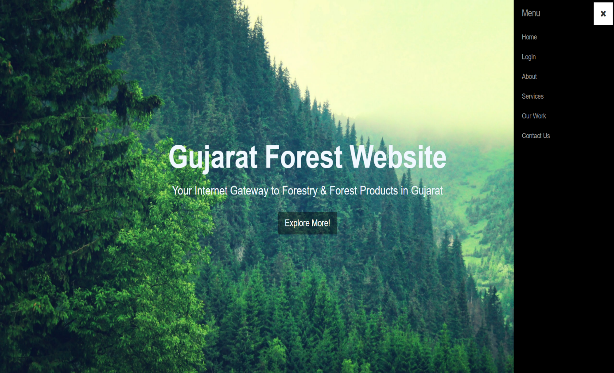

**\***fig 3.3.1 Home section of Homepage.



**\***fig 3.3.2 Login section of Homepage.

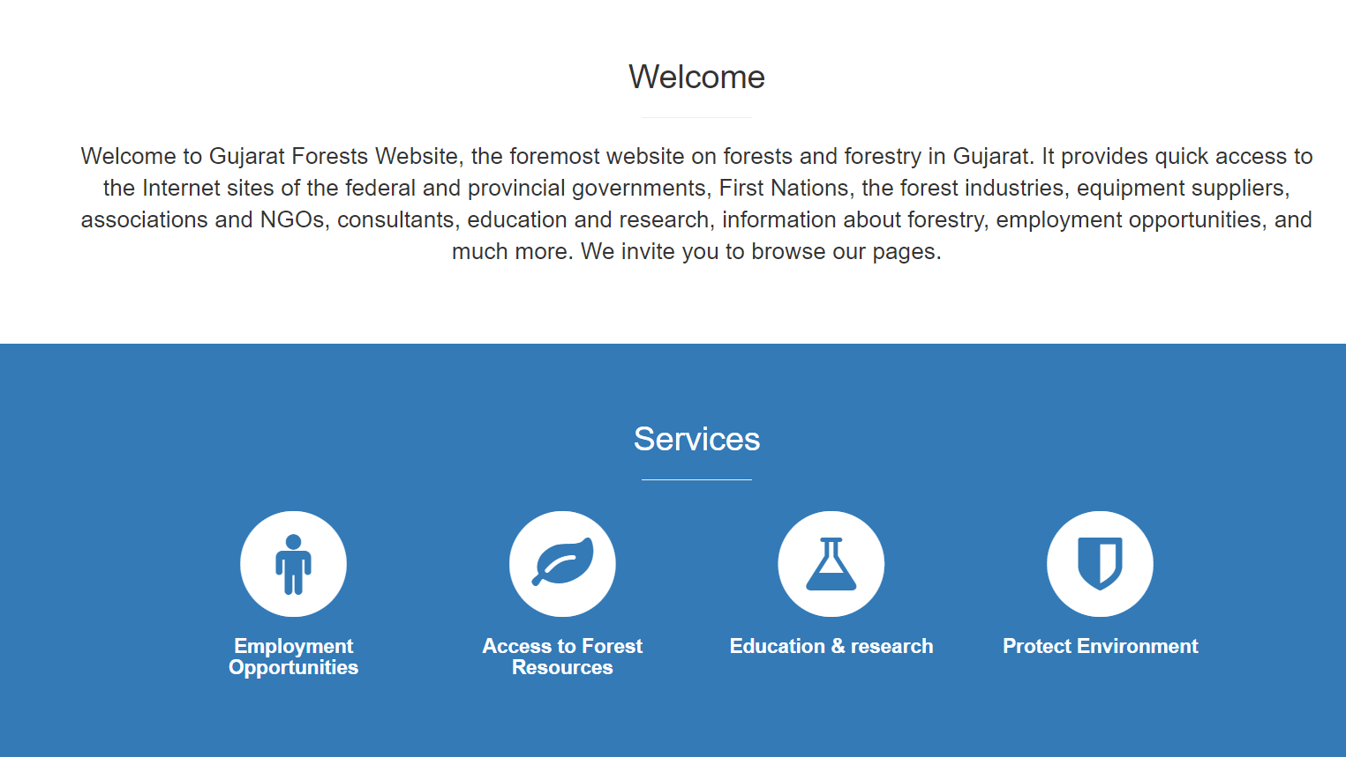

**\***fig 3.3.3 About and Service section of Homepage.

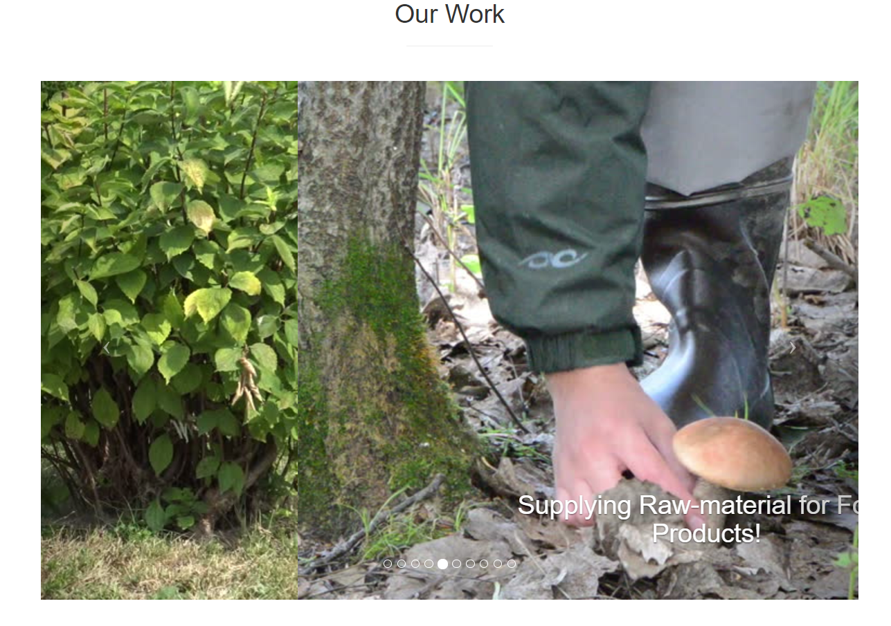

**\***fig 3.3.4 Our Work section of Homepage.

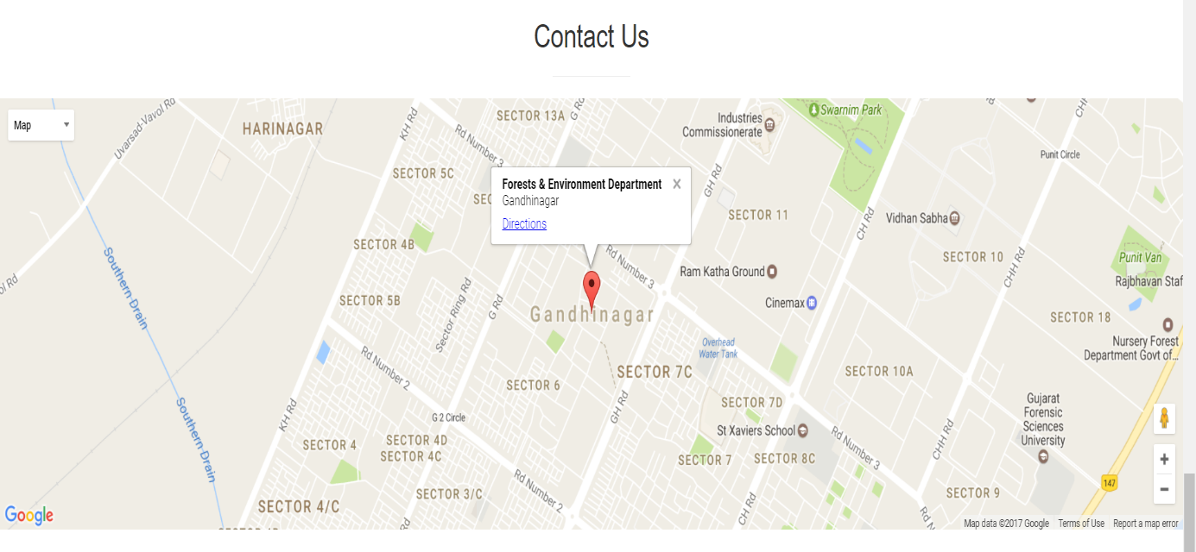

**\***fig 3.3.5 Contact Us section of Homepage.

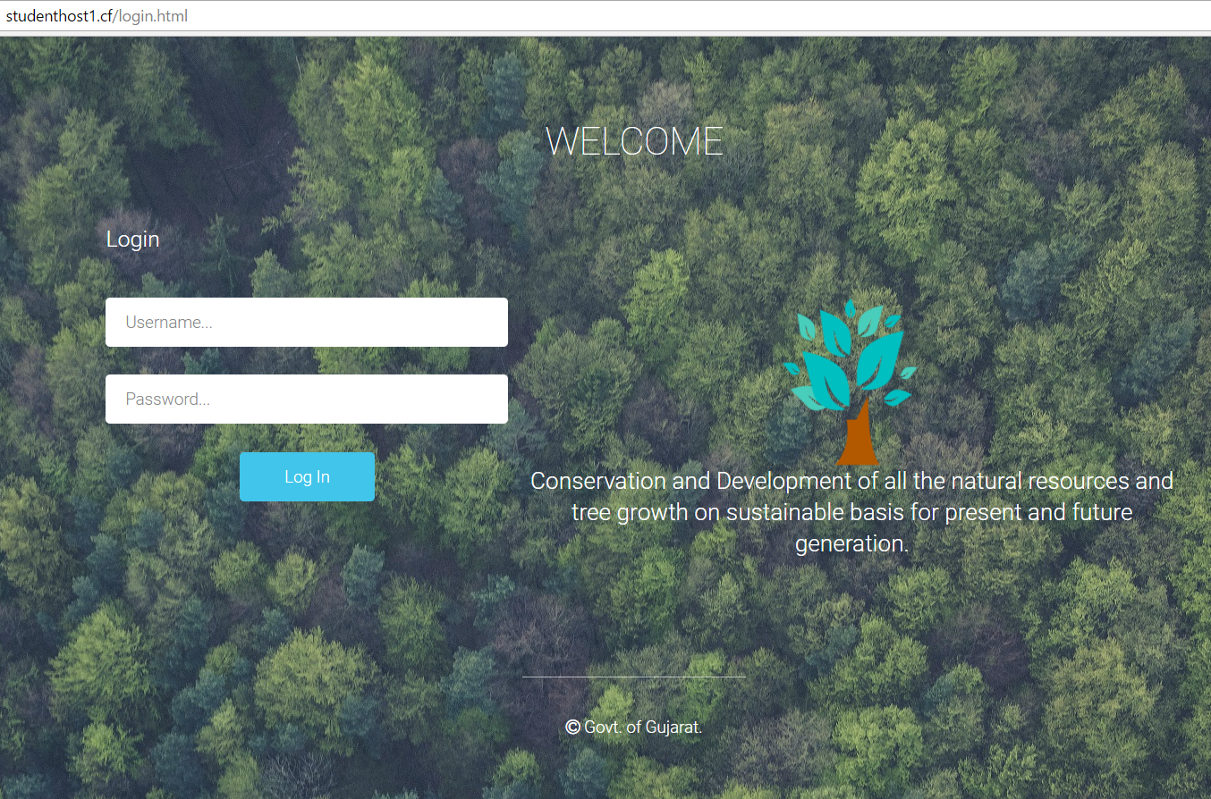

**\***fig 3.3.6 Login page of Project.

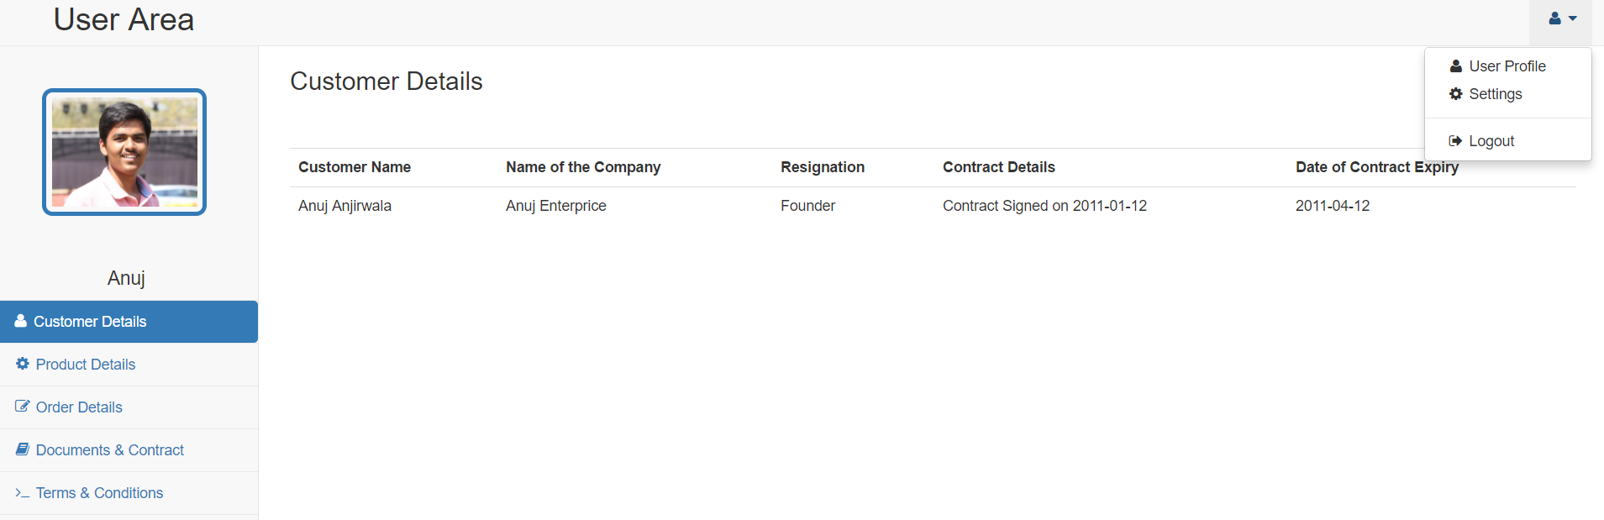

**\***fig 3.3.7 Customer Details section of User Area

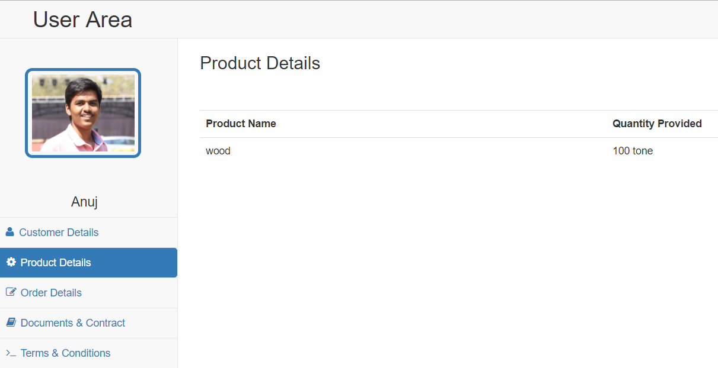

**\***fig 3.3.8 Product Details section of User Area

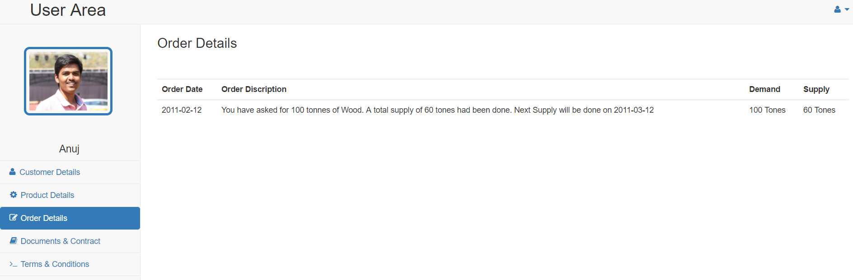

**\***fig 3.3.9 Order Details section of User Area

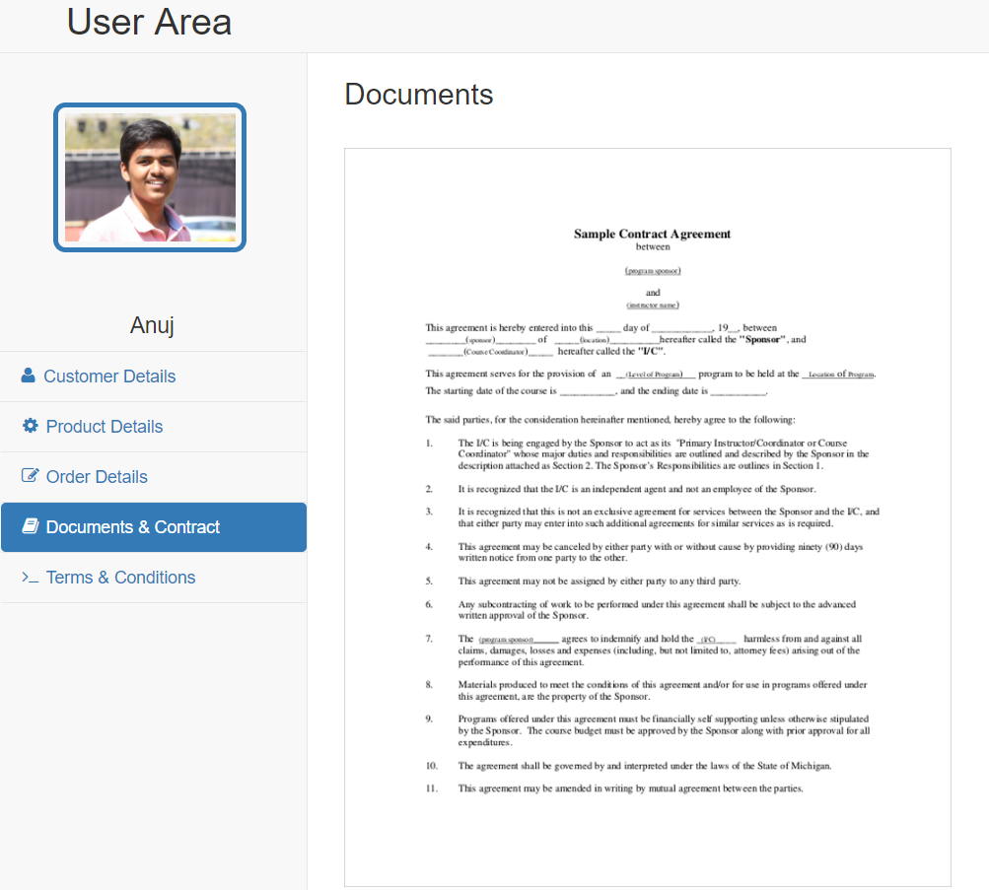

**\***fig 3.3.10 Document section of User Area

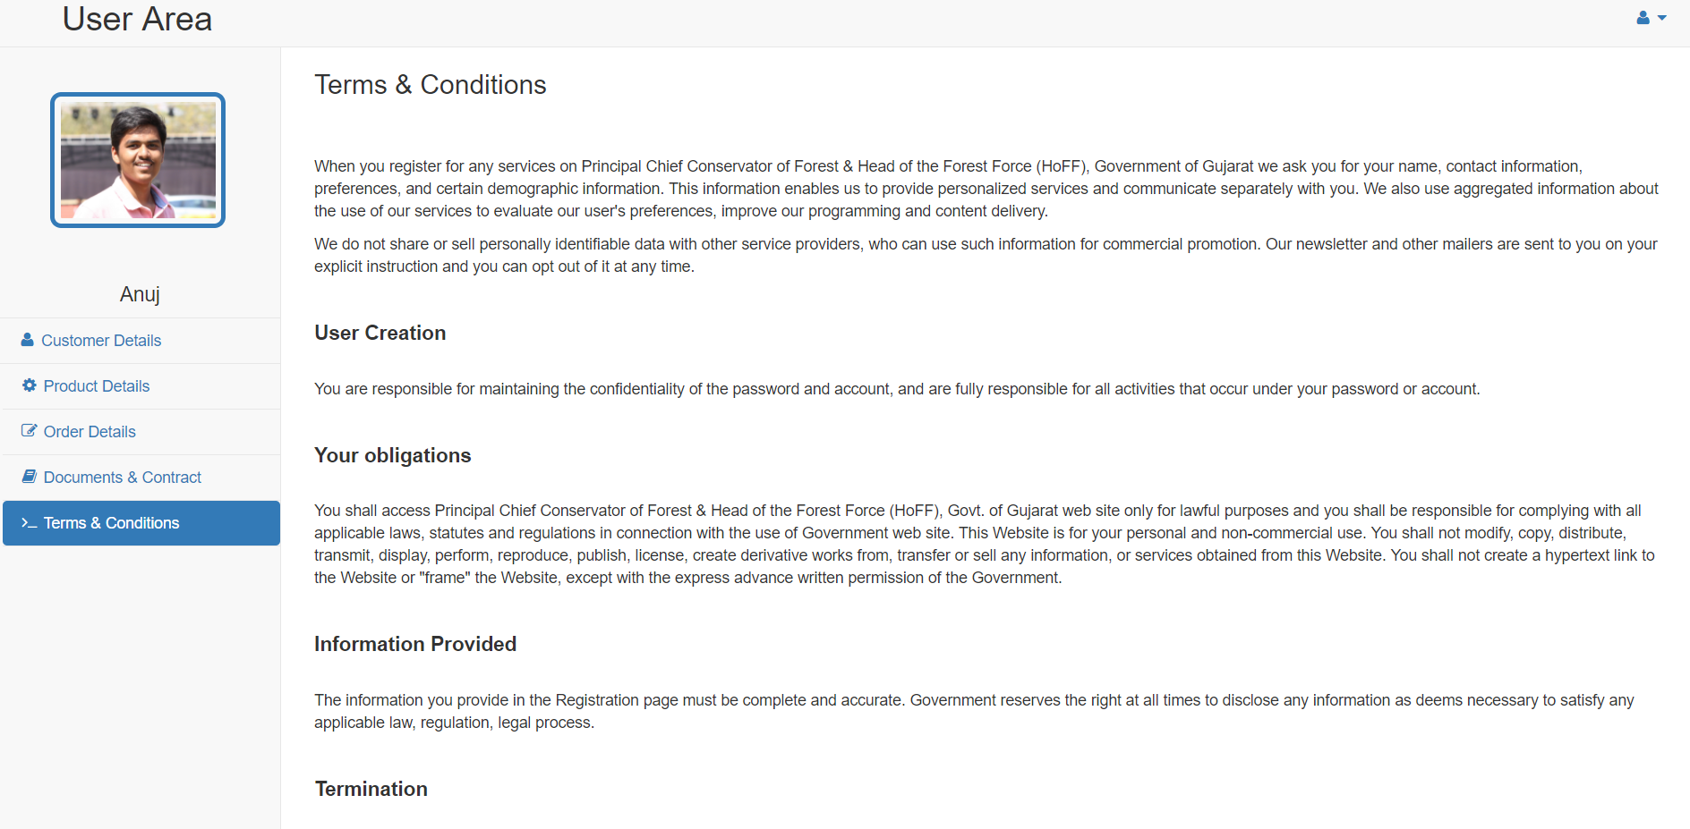

**\***fig 3.3.11 Terms and Condition sections of User Area

**CHAPTER 4**

**DATABASE DESIGN**

1. **DATABASE DESIGN**

The design of database is shown below in following diagram:

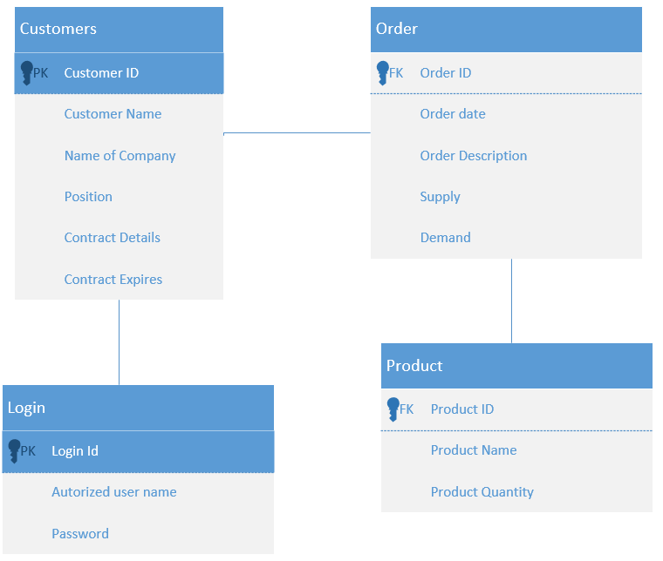

**\***fig 4.1 Database Design

1. **CORE DATABASE CONCEPTS**

* Primary Key: - It is Candidate Key with No NULL value. Primary key is a unique key.
* Candidate Key: - It is Super key without redundancy. In database, there can be more than one candidate key. It is depends on database designer who choose one unique and make it primary key.
* Foreign Key: - It is a key which point to the primary key of another table. It is used to link two table together.

1. **SCREENSHOTS OF DATABASE**

There are 4 table used in database construction as shown in figure above. Table description Screenshot is as given below:

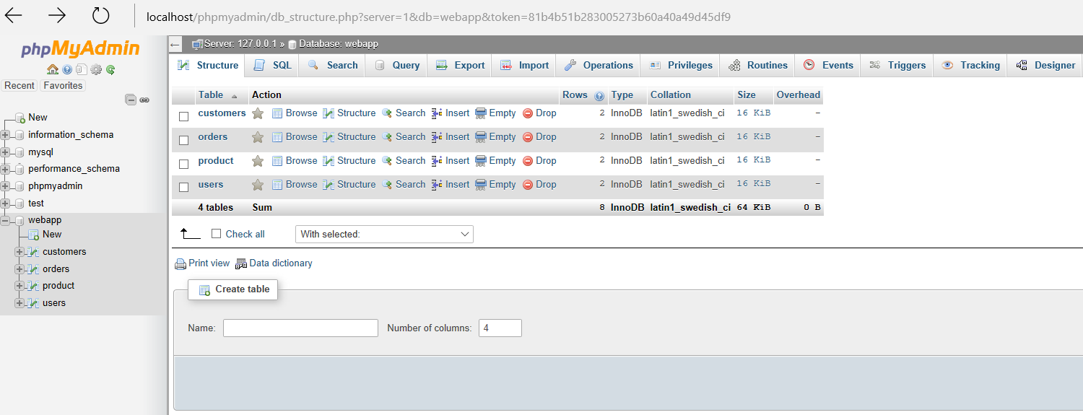

**\***fig 4.2 Overview of Table in Database

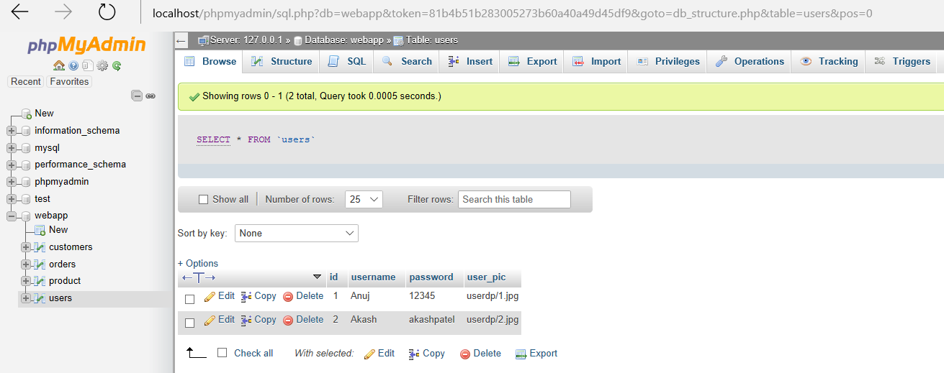

*fig 4.3 User Table

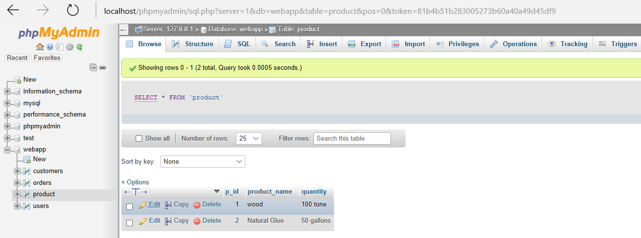

**\***fig 4.4 Product Table

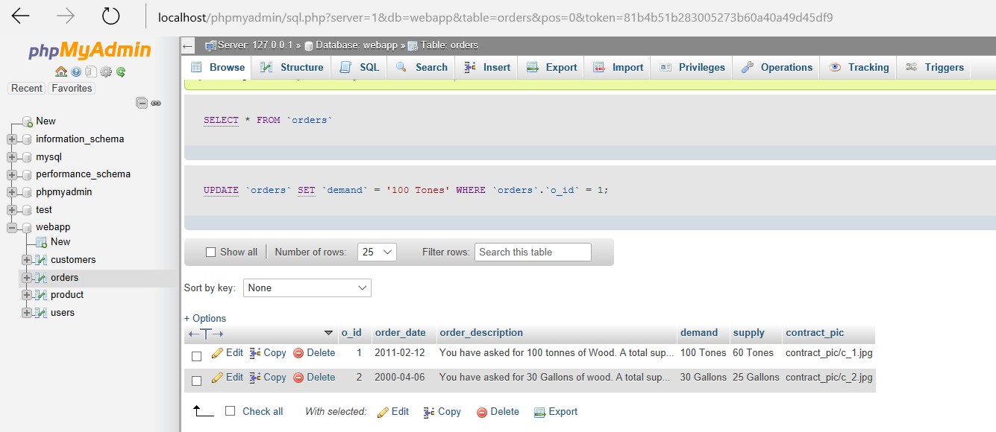

**\***fig 4.5 Order Table

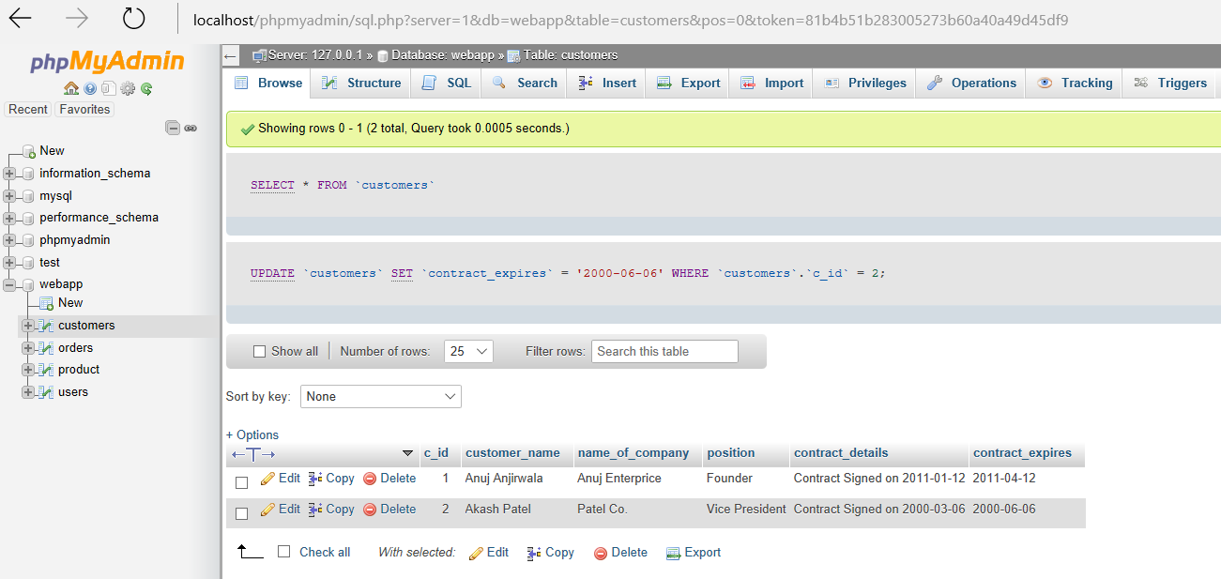

**\***fig 4.6 Customer Table

**CHAPTER 5**

**CONCLUSION**

The project **FOREST SALE AUTOMATION** is for maintaining the Forest sale online instead of working manually. Online web app is faster and more secure than offline work. It provides more facility and easily accessible from anywhere to any system as it is a web app.

**5.1 REFERENCES**

1. Laura Lemay, Rafe Colburn, Jennifer Kyrnin, *Mastering HTML, CSS & JavaScript Web Publishing*, BPB Publications; First edition (15 July 2016).
2. Thomas Powell, *HTML & CSS: The Complete Reference, Fifth Edition,* McGraw Hill Education; 5th edition (8 March 2010).

**Appendix – A List of Useful Websites**

https://www.tutorialspoint.com/mysql/mysql-connection.htm https://www.w3schools.com/js/js_operators.asp

https://www.tutorialspoint.com/mysql/mysql-connection.htm